New Sample
- is only for administration user. Lab user cannot add, edit delete New Samples
- Add a Notes text field as the last field in New Sample

Add Test / Charges and Reference Ranges
- Add a 3rd toggle (you have Basic and Sex) add “No / Manual Tag) and have a textarea field

Reports
At this stage the tests that were set when adding a New Sample cannot be changed. Thus only allow selecting the type of report
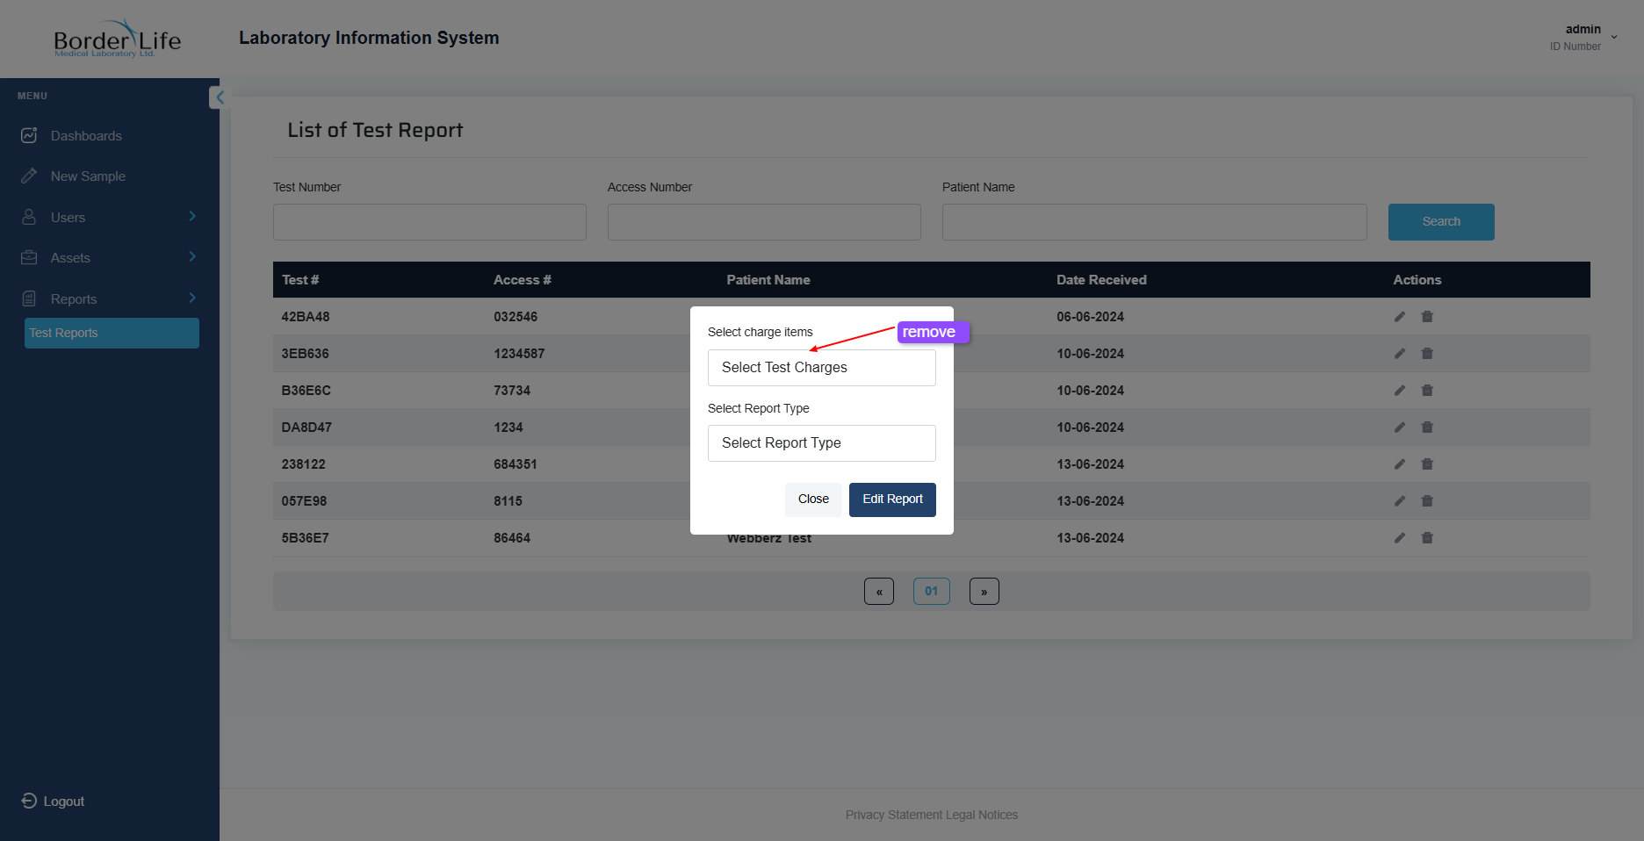

- The profile headings in reports are determined by test groups. This we did not know of before. This to be done by creating a way to create Profiles (groups of tests) and add, delete tests from the profile. Then when adding a New Sample in addition to selecting tests individually the admin can select a profile. I know this is new, please tell me if it affects cost as I will need to get approval from the client.

